**Read data from Properties file using Java Selenium**

In Selenium .properties files are mainly used to store GUI locators / elements, and also Global fields like database configuration details

'.properties' files are mainly used in Java programs to maintain project configuration data, database config or project settings etc. Each parameter in properties file is stored as a pair of strings, in key and value format, where each key is on one line. We can easily read properties from some file using object of type Properties.

**How to create properties file?**

Navigate to File menu -> New -> Click on File

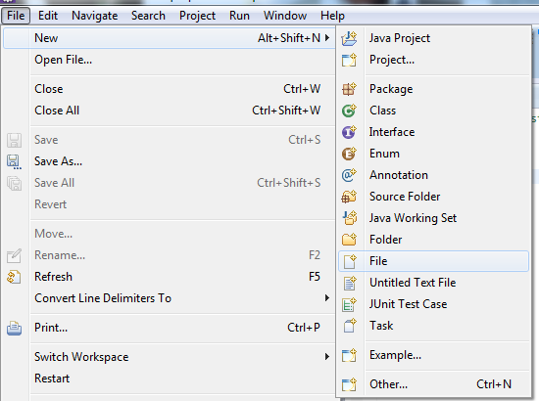

The only thing we need to do is, give the file name and give the extension as '.properties'. (Example: dataFile.properties)

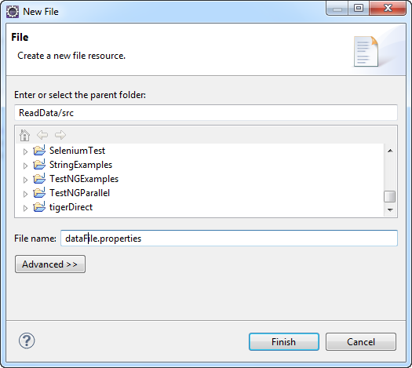

The properties file cannot have duplicate keys. you can have array of values returned for a supplied key.

key1=value1, value2,value3

the above key1 can return array of values.

The below is the sample properties file that will be used for the above tests. Remember white space between the property name and property value is always ignored. The following is the example.  
**username=testuser  
username = testuser**

In dataFile.properties file

# Global Properties

browser = chrome

# Login credentials

URL = http://newtours.demoaut.com/

userName = mercury

password = mercury

import java.io.File;

import java.io.FileInputStream;

import java.io.FileNotFoundException;

import java.io.IOException;

import java.util.Properties;

import org.openqa.selenium.By;

import org.openqa.selenium.WebDriver;

import org.openqa.selenium.WebElement;

import org.openqa.selenium.chrome.ChromeDriver;

import org.openqa.selenium.firefox.FirefoxDriver;

import org.testng.annotations.AfterMethod;

import org.testng.annotations.BeforeMethod;

import org.testng.annotations.Test;

public class MyFirstTestNGTestCase {

// Create object for browser driver

public static WebDriver driver;

public Properties prop;

public static String browsertype;

public static String exePath;

@Test

public void MyFirstTestNGTestCase1() throws InterruptedException {

String title = driver.getTitle();

System.out.print("Current page title is : " + title);

WebElement user = driver.findElement(By.name("userName"));

user.sendKeys(prop.getProperty("userName"));

WebElement pwd = driver.findElement(By.name("password"));

pwd.sendKeys(prop.getProperty("password"));

WebElement signin = driver.findElement(By.name("login"));

signin.click();

Thread.sleep(1000);

System.out.println("URL ::" + prop.getProperty("URL"));

System.out.println("User name::" +prop.getProperty("userName"));

System.out.println("Password::" +prop.getProperty("password"));

System.out.print("\n'SUCCESSFUL EXECUTION!!!");

}

@BeforeMethod

public void startFireFox() {

File file = new File("G:\\Selenium\\eclipse-workspace\\SeleniumIntroduction\\dataFile.properties");

FileInputStream fileInput = null;

try {

fileInput = new FileInputStream(file);

} catch (FileNotFoundException e) {

e.printStackTrace();

}

prop = new Properties();

//load properties file

try {

prop.load(fileInput);

} catch (IOException e) {

e.printStackTrace();

}

browsertype= prop.getProperty("browser");

if(browsertype.equalsIgnoreCase("chrome")) {

exePath = "G:\\Selenium RS 2019\\chromedriver_win32\\chromedriver.exe";

System.setProperty("webdriver.chrome.driver", exePath);

driver = new ChromeDriver();

}

else if(browsertype.equalsIgnoreCase("firefox")) {

exePath = "G:\\Selenium RS 2019\\geckodriver-v0.26.0-win32\\geckodriver.exe";

System.setProperty("webdriver.gecko.driver", exePath);

driver = new FirefoxDriver();

}

/*

System.setProperty("webdriver.chrome.driver", "G:\\Selenium RS 2019\\chromedriver_win32\\chromedriver.exe");

driver = new ChromeDriver();

*/

driver.manage().window().maximize();

driver.get(prop.getProperty("URL"));

}

@AfterMethod

public void cleaupProc() {

System.out.println("\n Browser closed");

driver.quit();

}

}

**Reference links:**

<https://www.seleniumeasy.com/selenium-tutorials/read-data-from-properties-file-using-java-selenium>

<https://www.swtestacademy.com/read-configurations-property-file-selenium/>

How to get all keys from properties file?

<https://www.java2novice.com/java-collections-and-util/properties/all-keys/>

<https://stackoverflow.com/questions/20511865/how-to-read-the-property-file-when-duplicate-key-value-pair-exist-in-the-file>

Write Properties File

<https://chercher.tech/java/properties-file-read-write-java-selenium-webdriver>

How to Remove Duplicates from a Property File Easily?

<https://technicles.com/remove-duplicates-properties-file-easy-way/>